**Automating webserver Deployment and Configuration Using Ansible Playbooks and Roles**

1)create ansible.cfg, inventory/hosts etc..

2)create the role

5)Add role task

6)Add handler

7)Create template

8)Create encrypted vault file

9)Run the Playbook

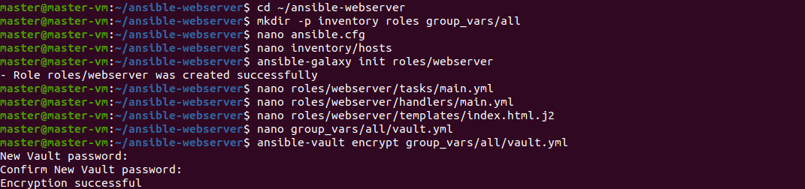

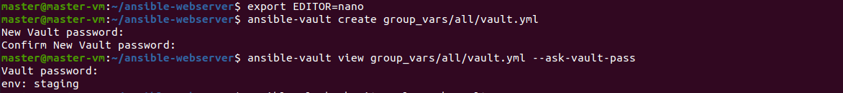

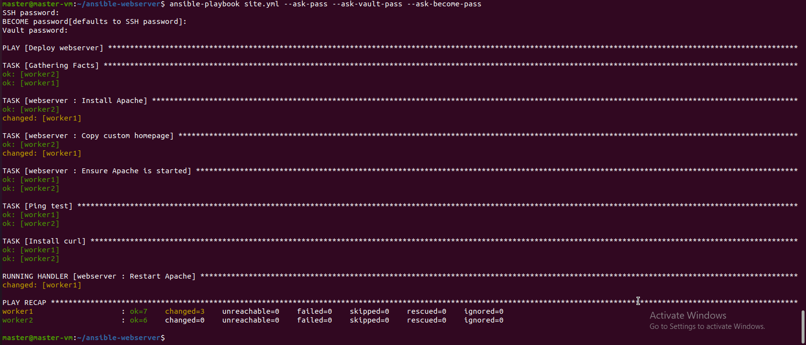

Output

